1.ReactJS-HOL
Objectives
- Understand the concept of Single Page Applications (SPA) and how they differ from Multi Page Applications (MPA)
- Explore the role and functionality of ReactJS in web development
- Learn about the Virtual DOM and how React uses it to enhance performance
- Highlight key features and advantages of ReactJS
- Set up a development environment for React
- Create a basic React application using create-react-app
Learning Outcomes
By completing this lab, students will be able to:
- Set up the environment for React development
- Create a basic ReactJS application using the CLI
- Modify React components and render custom content
- Understand the build and execution flow of a React application

Tools Required
Ensure the following tools are installed before beginning the lab:
- Node.js (Recommended LTS version)
- NPM (Node Package Manager) – usually installed along with Node.js
- Visual Studio Code – or any preferred code editor

Notes
Estimated time to complete this lab: 30 minutes.
Create a new React Application with the name “myfirstreact”, Run the application to print “welcome to the first session of React” as heading of that page.
- To create a new React app, Install Nodejs and Npm from the following link:
https://nodejs.org/en/download/
- Install Create-react-app by running the following command in the command prompt:

- To create a React Application with the name of “myfirstreact”, type the following command:

- Once the App is created, navigate into the folder of myfirstreact by typing the following command:
- Open the folder of myfirstreact in Visual Studio Code
- Open the App.js file in Src Folder of myfirstreact
- Remove the current content of “App.js”
- Replace it with the following:

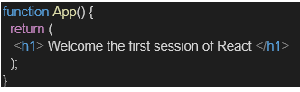

- Run the following command to execute the React application:

- Open a new browser window and type “localhost:3000” in the address bar

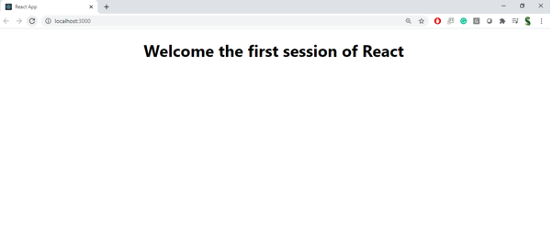
EXECUTIONS:
App.js:
import React from 'react';
function App() {
return (
<div>
<h1>Welcome to the first session of React</h1>
</div>
);
}
export default App;

OUTPUT:
